Abstract

**Abstract**

**Title:-**

Digital Attendance Application

**Introduction:-**

Project is a task for the students for generating their ability along with their talent. Now we can create a project of Digital Attendance Application. This is project or application will be made to reduce the paper work of people.

This application is created for the ease and maintenance of student attendance. It generates the absent list with the student details like Roll No., Name and Contact No. All reports are stored in MS Access as well as text file format. For security purpose, authentication processes are also implemented in which staff/user will have to provide Username, Password and Pass key (i.e. picture). Also this system will calculate and provide the student’s attendance percentage for every session. This application has been designed using Visual Basic 6.0 as front end and MS-Access as Database.

We made this project in visual basic 6.0 software. The database is operate through the internally by visual basic data manager. The data will be stored by the date wise in the specific folder.

This project will be used to reduce the paper work and also reduce the time. In this project we provide the three types of security: 1. User ID Detection 2. Password Security 3. Image Analyzer without passing this security we cannot access the attendance application.

**Forms:-**

1. Main Form
2. Start Option
3. Three level of Login Security

a. User ID Detection

b. Password Security

c. Image Analyzer

2. Selection Of Department

1. BCA
2. BSC
3. B.COM
4. BA

3. Selection of Class-

a.IstYear

b. IInd Year

c. IIIrd Year

4. Attendance Sheet

5. Overall View of Attendance Report

6. Absent students list

7. Data Storing Mechanism

8. Data Preview which store in the database

1. Restart Option
2. Open Database
3. Register
4. Search
5. Sign up
6. Help
7. About
8. Exit

**Software:-**

Front End:

Visual Basic 6.0

**Database:-**

Back End:

MS-Access

**Team Member:-**

1. Shubham R. Surve

2. Sachin R. Mokale

3. Aman V. Vishwakarma

4. Deepak B. Deshmukh

Introduction

**Introduction to Visual Basic**

* Visual Basic is a programming language and development environment created by Microsoft.
* Visual Basic provides a graphical user interface GUI that allows the developer drag and drop objects into the program as well as manually write program code.
* Visual Basic, also referred to as "VB," is designed to make software development easy and efficient

**Visual Basic 6.0**

1. Visual Basic is a programming language and integrated development environment.
2. It derives from the much older BASIC programming language, and so is considered useful and easy programming language for the beginner to learn.
3. Visual Basic 6.0 was the final edition of Visual Basic.

**Feature Of visual basic 6.0**

1. Learning Consists of all necessary tools required to build main stream Windows Applications
2. Professional Includes advanced features such as tools to develop ActiveX and Internet controls.
3. Enterprise In addition to all Professional features, it also includes tools such as Visual

**Features of visual basic**

1. GUI Interface
2. Modularization
3. Object Oriented
4. Debugging
5. Macros IDE
6. Data access feature

**Guo Interface**: -

VB is a Graphical User Interface language. This means that a VB program will always show something on the screen that the user can interact with to get a job done.

**Modularization**: -

It is considered good programming practice to modularize your programs. Small modules where it is clearly indicated what comes into the module and what goes out makes a program easy to understand.

**Object Oriented**: -

Object Oriented Programming is a concept where the programmer thinks of the program in "objects" that interact with each other. Visual Basic forces this good programming practice.

**Debugging**: -

Visual Basic offers two different options for code debugging:- Debugging Managed Code Runtime Debugger The Debugging Managed Code individually debugs C and C++ applications and Visual Basic Windows applications. The Runtime Debugger helps to find and fix bugs in programs at runtime.

**Data Access Feature**: -

By using data access features, we can create databases, scalable server-side components for most databases, including Microsoft SQL Server and other enterprise-level database.

**Macros IDE**: -

The Macros integrated development environment is similar in design and function to the Visual Studio IDE. The Macros IDE includes a code editor, tool windows, the properties windows and editors.

**Introduction To MS-Access**

Microsoft Access is a computer application used to create and manage computer-based databases on desktop computers and/or on connected computers (a network). Microsoft Access can be used for personal information management (PIM), in a small business to organize and manage data, or in an enterprise to communicate with servers.

Like any other computer application, in order to use Microsoft Access, you must first install it. After installing Microsoft Access, then you can open it. There are various ways you can open Microsoft Access. It gets launched like the usual products you have probably been using. As such, to start this program, you could click Start -> (All) Programs -> Microsoft Office -> Microsoft Office Access 2007. You can also launch it from Windows Explorer or My Computer. To do this, locate its shortcut in Windows Explorer or My Computer. By default, Microsoft Access 2007 is located in C:\Program Files\Microsoft Office\Office12 and its shortcut is called MSACCESS.EXE. Once you have located it, you can then double-click it.

If you have a Microsoft Access database such as an E-Mail attachment, a file on a floppy disk, on the network, or in any other means, once you see its icon, you can double-click it. Not only will this action launch Microsoft Access, but also it will open the file.

You can also launch Microsoft Access from a shortcut. If you happen to use the software on a regular basis, you can create a shortcut on your desktop or on the Quick Launch area.

If you are working on a network of related computers, your database may be located in another computer. In this case the network or database administrator would create a link or shortcut to the drive that is hosting the database. You can then click or double-click this link or shortcut to open the database and, as a result, launch Microsoft Access.

The Database as a File

A Microsoft Access database is primarily a Windows file. It must have a location, also called a path, which indicates how the file can be retrieved and made available. Although you can create a database on the root directory such as the C: drive, it is usually a good idea to create your files, including your databases, in an easily recognizable folder.

When you installed the computer (or when it was installed), it (the operating system) might have created a folder called My Documents that provides a convenient place for you to create your files. If various people use the same computer, there is a different My Documents folder for each one. When you log in, the computer (the operating system) locates your corresponding My Documents folder and makes it available.

Creating Database

In our lessons, we will learn different techniques of creating a database. For now, a database is first of all a Windows file. It is mainly created from Microsoft Access. If you have just started Microsoft Access, to create a database, you can use one of the links in the main (middle section of the interface).

You can proceed from one of these options. Like every file in the computer, a database must have a name that identifies it. This name must be specified when creating the database.

In our description of the Microsoft Access interface, we saw that the right section displayed an empty area. If you start creating a database as we will see in the next sections and lessons, the right side gets filled with some options, such as prompting you to name your database.

Database Properties

Whether you work alone or in a group, communication and documentation are important. Your database project has its own properties that you can use to find out some details about your file, to enter some notes about the project, or to give directives to other people who have access to the database. This can be done using a dialog box called the Database Properties. To access it, you can click the Office Button -> Manage -> Database Properties.

Feasibility Study

**Economically Feasibility:**

The system being developed is economic with respect to School or Collage’s point of view. It is cost effective in the sense that has eliminated the paper work completely.

The system is also time effective because the calculations are automated which are made at the end of the month or as per the user requirement.

The result obtained contains minimum errors and are highly accurate as the data is required.

**Technical feasibility:**

The technical requirement for the system is economic and it does not use any other additional Hardware and software.

**Behavioural Feasibility:**

The system working is quite easy to use and learn due to its simple but attractive interface. User requires no special training for operating the system.

Data Tables

**Database:-**

|  |  |
| --- | --- |
| Field Name | Data Type |
| DATE | Date/Time |
| DEPT | Text |
| CLASS | Text |
| LECTURAL | Text |
| LOGIN_SESSION | Date/Time |
| LOGOUT_SESSION | Date/Time |
| PRESENT | Number |
| ABSENT | Number |

**Stu_Database:-**

|  |  |
| --- | --- |
| Field Name | Data Type |
| Rollno | Number |
| Stu_name | Text |
| Present | Number |
| absent | Number |

**Sign_Up:-**

|  |  |
| --- | --- |
| Field Name | Data Type |
| User_id | Text |
| Password | Text |
| image | Text |

Data Flow Diagram

Exit

Display the Developer’s & Application

Information

About

Help

Sign up

Search

Registering new Student in the Student Database

Register

Display the Data Base of Various Department

Open DataBase

Restart

Attendance Data Store in the Format of Text File as well as Store in Access record

Attendance Sheet according to class

Class (Year)

Selection

Department Selection

1) User Id Authentication

2) Password Security

3) Image Analyser

3 Level of Security

START Button

**Main Form**

Terminate Application

Display help about application

Restart Button to reset the application

Register a New User

Display the List of Selected Department Student list

Design and Coding

**Main Form:**

The main form includes the menus like Restart, Open Data base, Register, Sign up, Search, Help, About and Exit.

The main form also includes of the start button to start up the Attendance Process (with three level of login security).

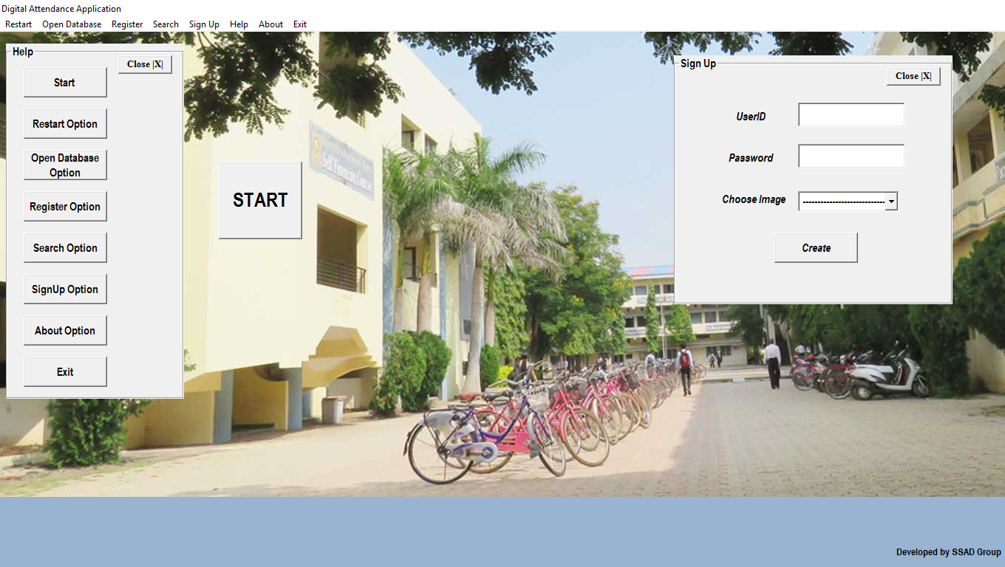

Public sel As Integer

Private Sub About_Click()

Form15.Show

End Sub

Private Sub BA_Click()

sel = 3

Form16.Show

End Sub

Private Sub BCA_Click()

sel = 0

Form16.Show

End Sub

Private Sub BCom_Click()

sel = 2

Form16.Show

End Sub

Private Sub BSC_Click()

sel = 1

Form16.Show

End Sub

Private Sub Command1_Click()

Form1.Show

Form1.Text1.Text = ""

Form2.Text2.Text = ""

Form2.Text1.SelText = ""

Form11.Command1.Visible = True

Form11.Command2.Visible = True

Form11.Command3.Visible = True

Form11.Command4.Visible = False

Form11.Command5.Visible = False

Form11.Command6.Visible = False

Form4.Text1.Text = ""

Form5.Label1.Caption = " "

Form5.Label2.Caption = " "

Form5.Label3.Caption = " "

Form5.Label4.Caption = " "

Form6.Label1.Caption = " "

Form6.Label2.Caption = " "

Form6.Label3.Caption = " "

Form6.Label4.Caption = " "

Form9.Text1.Text = ""

Form10.Text1.Text = ""

Form10.Text2.Text = ""

Form10.Text3.Text = ""

Form10.Text4.Text = ""

End Sub

Private Sub Command10_Click()

Frame3.Caption = Command10.Caption

Frame3.Visible = True

Command12.Visible = True

Text3.Visible = True

Text3.Text = "End the Application"

End Sub

Private Sub Command11_Click()

Frame2.Visible = False

Command3.Visible = False

Command4.Visible = False

Command5.Visible = False

Command12.Visible = False

Frame3.Visible = False

Frame3.Caption = ""

Text3.Text = ""

Text3.Visible = False

End Sub

Private Sub Command12_Click()

Frame3.Visible = False

Text3.Visible = False

Text3.Text = ""

Command12.Visible = False

End Sub

Private Sub Command19_Click()

Frame1.Visible = False

Label2.Visible = False

Label3.Visible = False

Label4.Visible = False

Text1.Visible = False

Text2.Visible = False

Combo1.Visible = False

Command2.Visible = False

Text1.Text = ""

Text2.PasswordChar = ""

Text2.Text = ""

Text2.PasswordChar = "*"

Combo1.ListIndex = 0

Command19.Visible = False

End Sub

Private Sub Command2_Click()

If Text1.SelLength = 0 & Text2.SelLength = 0 Then

MsgBox "Please Dont Leave it Blank"

Text1.Text = ""

Text1.SetFocus

Text2.Text = ""

Else

Data1.Recordset.Fields("user_id").Value = Text1.Text

Data1.Recordset.Fields("password").Value = Text2.Text

Data1.Recordset.Fields("image").Value = Combo1.Text

Data1.Recordset.Update

Frame1.Visible = False

Label2.Visible = False

Label3.Visible = False

Label4.Visible = False

Text1.Visible = False

Text2.Visible = False

Combo1.Visible = False

Command2.Visible = False

End If

End Sub

Private Sub Command3_Click()

Frame3.Caption = Command3.Caption

Frame3.Visible = True

Command12.Visible = True

Text3.Visible = True

Text3.Text = "Start >>UserID Authentication >> Password Security >> Image Analyzer>> Department Selection >>Class(Year) Selection >> Attendance Sheet >> Attendance Report >> Absent Student List >> Storing Attendance Data into DataBase& Exit "

End Sub

Private Sub Command4_Click()

Frame3.Caption = Command4.Caption

Frame3.Visible = True

Command12.Visible = True

Text3.Visible = True

Text3.Text = "Restart the Appication"

End Sub

Private Sub Command5_Click()

Frame3.Caption = Command5.Caption

Frame3.Visible = True

Command12.Visible = True

Text3.Visible = True

Text3.Text = "Display the Overall Attendace Database of all Department, you can sort the Database by the selected Department as well as Class(Year"

End Sub

Private Sub Command6_Click()

Frame3.Caption = Command6.Caption

Frame3.Visible = True

Command12.Visible = True

Text3.Visible = True

Text3.Text = "Registeration of a New student"

End Sub

Private Sub Command7_Click()

Frame3.Caption = Command7.Caption

Frame3.Visible = True

Command12.Visible = True

Text3.Visible = True

Text3.Text = "Searching of a student for lookup the attendace for his/her"

End Sub

Private Sub Command8_Click()

Frame3.Caption = Command8.Caption

Frame3.Visible = True

Command12.Visible = True

Text3.Visible = True

Text3.Text = "Create a New Login Account, but with Admin PassKey you can Enter into the SignUp Process"

End Sub

Private Sub Command9_Click()

Frame3.Caption = Command9.Caption

Frame3.Visible = True

Command12.Visible = True

Text3.Visible = True

Text3.Text = "Display the Application Developer & Designer Information"

End Sub

Private Sub Exit_Click()

End

End Sub

Private Sub Form_Load()

Combo1.AddItem "Image 1"

Combo1.AddItem "Image 2"

Combo1.AddItem "Image 3"

Combo1.AddItem "Image 4"

End Sub

Private Sub Help_Click()

Frame2.Visible = True

Command3.Visible = True

Command4.Visible = True

Command5.Visible = True

Command6.Visible = True

Command12.Visible = False

Frame3.Visible = False

Frame3.Caption = ""

Text3.Text = ""

Text3.Visible = False

End Sub

Private Sub Open_Click()

Form14.Show

End Sub

Private Sub Restart_Click()

Form1.Refresh

Form2.Refresh

Form3.Refresh

Form4.Refresh

Command1.Enabled = True

End Sub

Private Sub Search_Click()

On Error GoTomsg

msg:

MsgBox "Welocme to Search Engine of Student", vbOKOnly, "Message"

Form17.Show

Exit Sub

End Sub

Private Sub SignUp_Click()

Dim ip As String

ip = InputBox("Enter the Secure Pass-Key for register new login account", "Security Warning")

If ip = "" Then

MsgBox "Dont leave it Blank", vbOKOnly, "Error"

Else

If ip = "RAC@Washim" Then

Frame1.Visible = True

Label2.Visible = True

Label3.Visible = True

Label4.Visible = True

Text1.Visible = True

Text2.Visible = True

Combo1.Visible = True

Command19.Visible = True

Command2.Visible = True

Text1.SetFocus

Data1.Recordset.AddNew

Else

MsgBox "Please Enter the correct the Pass-Key", vbOKOnly, "Invalid Pass-Key"

End If

End If

End Sub

**User ID form:**

It consist of a valid and also unique user ID to Pass out the first level of security i.e. User ID detection.

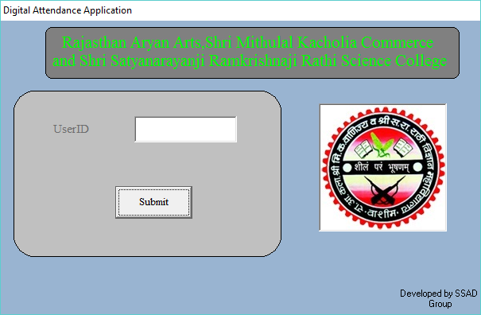

Private Sub Command1_Click()

Form2.Text6.Text = 3

Form3.Text6.Text = 3

Data1.RecordSource = "select * from account where user_id='" + Text1.Text + "'"

Data1.Refresh

Form2.Text1.PasswordChar = 0

Form2.Text1.Text = ""

Form2.Text1.PasswordChar = "*"

If Text1.Text = "" Then

MsgBox "Dont let this Box Empty", vbInformation, "Error"

Else

If Data1.Recordset.EOF Then

MsgBox "You Have Enter a Invalid UserId, Please Enter the Correct one", vbCritical, "Message"

Text1.Text = ""

Text1.SetFocus

Else

Form2.Show

Me.Hide

Form2.Text2.Text = Text1.Text

Form2.i = 1

Form3.i = 1

End If

End If

End Sub

Private Sub Form_Load()

Me.Hide

Form12.Show

End Sub

**Password Form:**

It consist of a valid Password to Pass out the second level of security i.e. Password Security which include three attempts for login.

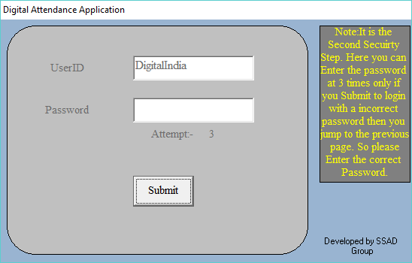

Public iAs Integer

Private Sub Command1_Click()

Data1.RecordSource = "select * from account where user_id ='" + Text2.Text + "' And password='" + Text1.Text + "' "

Data1.Refresh

If i = 3 Then

MsgBox "You have Many Time Wrong Attempts, Please start

again from the UserID Authentication", vbCritical, "Warning"

Form1.Show

Me.Hide

Form1.Text1.Text = ""

Form3.Text1.Text = ""

Else

If Text1.Text = "" Then

MsgBox "Dont let this Box Empty", vbInformation, "Error"

Else

If Data1.Recordset.EOF Then

MsgBox "You Enter a Wrong Password", vbOKOnly, "Incorrect Password"

Text1.SetFocus

Text1.PasswordChar = 0

Text1.Text = ""

Text1.PasswordChar = "*"

i = i + 1

Text6.Text = Val(Text6.Text) - 1

Else

Form3.Show

Me.Hide

Form3.Option1.Value = False

Form3.Option2.Value = False

Form3.Option3.Value = False

Form3.Option4.Value = False

End If

End If

End If

End Sub

Private Sub Form_Load()

i = 1

End Sub

**Image analyser Form:**

This is the Last level of authentication i.e. Image Analyser which includes ten various Images but only one image act as a pass key to proceed the next step.

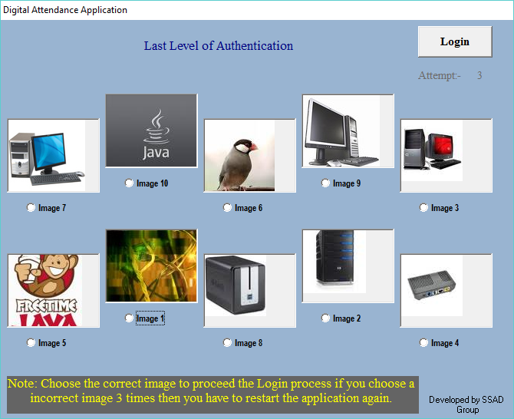

Public iAs Integer

Private Sub Command1_Click()

Data1.RecordSource = "select * from account where user_id ='" + Form2.Text2.Text + "' And password='" + Form2.Text1.Text + "' And image='" + Text1.Text + "' "

Data1.Refresh

If i = 3 Then

MsgBox "Please Restart the application, You have Many Time Wrong Attempts", vbCritical, "Warning"

Form12.Show

Form12.Command1.Enabled = False

Else

If Text1.Text = "" Then

MsgBox "Dont let this Box Empty", vbInformation, "Error"

Else

If Data1.Recordset.EOF Then

MsgBox "You have Choose a Wrong Image", vbCritical, "Access Denied"

i = i + 1

Text6.Text = Val(Text6.Text) - 1

Else

Form11.Show

Me.Hide

Text1.Text = ""

End If

End If

End If

End Sub

Private Sub Form_Load()

i = 1

End Sub

Private Sub Option1_Click()

Text1.Text = Option1.Caption

End Sub

Private Sub Option2_Click()

Text1.Text = Option2.Caption

End Sub

Private Sub Option3_Click()

Text1.Text = Option3.Caption

End Sub

Private Sub Option4_Click()

Text1.Text = Option4.Caption

End Sub

Private Sub Option5_Click()

Text1.Text = Option5.Caption

End Sub

Private Sub Option6_Click()

Text1.Text = Option6.Caption

End Sub

Private Sub Option7_Click()

Text1.Text = Option7.Caption

End Sub

Private Sub Option8_Click()

Text1.Text = Option8.Caption

End Sub

Private Sub Option9_Click()

Text1.Text = Option9.Caption

End Sub

Private Sub Option10_Click()

Text1.Text = Option10.Caption

End Sub

**Department Form:**

This form include the three fields Science, Commerce and Arts. Which also include department like BSC, BCA, B.COM, B.A.

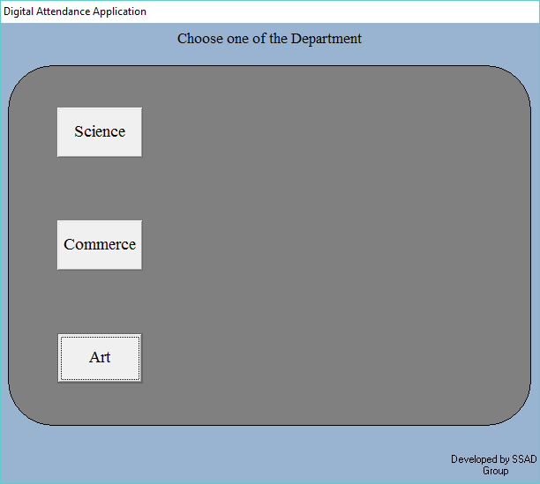

Public chAs Integer

Public ss, sr, l1 As String

Private Sub Command1_Click()

Form8.Text22.Text = Command1.Caption

Command8.Visible = True

Command4.Visible = True

Command5.Visible = True

Command2.Visible = False

Command3.Visible = False

ss = Command1.Caption + "-"

End Sub

Private Sub Command2_Click()

Form8.Text22.Text = Command2.Caption

Command8.Visible = True

Command6.Visible = True

Command1.Visible = False

Command3.Visible = False

ss = Command2.Caption + "-"

End Sub

Private Sub Command3_Click()

Form8.Text22.Text = Command3.Caption

Command8.Visible = True

Command7.Visible = True

Command1.Visible = False

Command2.Visible = False

ss = Command3.Caption + "-"

End Sub

Private Sub Command4_Click()

l1 = "C:\Database\Science\B.S.C\"

Form8.Text19.Text = Command4.Caption

Form4.Show

Me.Hide

Form8.Text17.Text = Command4.Caption + " "

sr = ss + "-" + Command4.Caption

ch = 0

End Sub

Private Sub Command5_Click()

l1 = "C:\Database\Science\B.C.A\"

Form8.Text19.Text = Command5.Caption

Form4.Show

Me.Hide

Form8.Text17.Text = Command5.Caption + " "

sr = ss + "-" + Command5.Caption

ch = 1

End Sub

Private Sub Command6_Click()

l1 = "C:\Database\Commerce\B.Comm\"

Form8.Text19.Text = Command6.Caption

Form4.Show

Me.Hide

Form8.Text17.Text = Command6.Caption + " "

sr = ss + "-" + Command6.Caption

ch = 2

End Sub

Private Sub Command7_Click()

l1 = "C:\Database\Arts\B.A\"

Form8.Text19.Text = Command7.Caption

Form4.Show

Me.Hide

Form8.Text17.Text = Command7.Caption + " "

sr = ss + "-" + Command7.Caption

ch = 3

End Sub

Private Sub Command8_Click()

Command8.Visible = False

Command1.Visible = True

Command2.Visible = True

End Sub

**Class Form:**

This form include three class i.e. first year, second year, and third year.

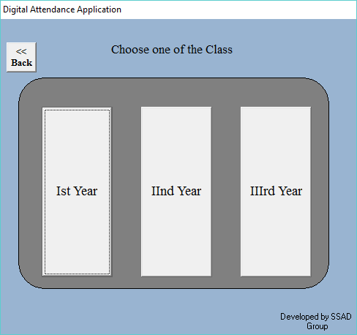

Public a, choice As Integer

Public n1, rs, l2 As String

Dim id, it As Date

Private Sub Command1_Click()

Command6.Visible = False

Label3.Visible = True

Command2.Visible = False

Command3.Visible = False

Text1.Visible = True

Label2.Visible = True

Command4.Visible = True

Form8.Text17.Text = Command1.Caption

a = 0

rs = Form11.sr + "-" + Command1.Caption

l2 = Form11.l1 + "Ist Year\"

End Sub

Private Sub Command2_Click()

Command6.Visible = False

Label3.Visible = True

Command1.Visible = False

Command3.Visible = False

Text1.Visible = True

Label2.Visible = True

Command4.Visible = True

Form8.Text17.Text = Command2.Caption

a = 1

rs = Form11.sr + "-" + Command2.Caption

l2 = Form11.l1 + "IInd Year\"

End Sub

Private Sub Command3_Click()

Command6.Visible = False

Label3.Visible = True

Command2.Visible = False

Command1.Visible = False

Text1.Visible = True

Label2.Visible = True

Command4.Visible = True

Form8.Text17.Text = Command3.Caption

a = 2

rs = Form11.sr + "-" + Command3.Caption

l2 = Form11.l1 + "IIIrd Year\"

End Sub

Private Sub Command4_Click()

If Text1.Text = "" Then

m = MsgBox("You cannot leave this box blank", vbOKOnly, "Warning")

Else

id = DateValue(Now)

it = TimeValue(Now)

Form8.Text6.Text = id

Form8.Text12.Text = it

n1 = Text1.Text

Form8.Text15.Text = n1

choice = Form11.ch

Select Case choice

Case 0

Form13.Show

Me.Hide

Case 1

If a = 0 Then

Form5.Show

Me.Hide

Form5.Timer1.Enabled = True

Form5.Timer2.Enabled = True

ElseIf a = 1 Then

Form6.Show

Me.Hide

Form6.Timer1.Enabled = True

Form6.Timer2.Enabled = True

ElseIf a = 2 Then

Form7.Show

Me.Hide

Form7.Timer1.Enabled = True

Form7.Timer2.Enabled = True

End If

Case 2

Form18.Show

Me.Hide

Case 3

Form19.Show

Me.Hide

End Select

End If

End Sub

Private Sub Command6_Click()

Form11.Command8.Visible = False

Form11.Command4.Visible = False

Form11.Command5.Visible = False

Form11.Command6.Visible = False

Form11.Command1.Visible = True

Form11.Command2.Visible = True

Form11.Command3.Visible = True

Label2.Visible = False

Command4.Visible = False

Text1.Visible = False

Command1.Visible = True

Command2.Visible = True

Command3.Visible = True

Command6.Visible = False

Text1.Text = ""

Me.Hide

Form11.Show

End Sub

Private Sub Form_Load()

Me.Refresh

End Sub

Private Sub Label3_Click()

Label2.Visible = False

Command4.Visible = False

Text1.Visible = False

Command1.Visible = True

Command2.Visible = True

Command3.Visible = True

Command6.Visible = True

Label3.Visible = False

Text1.Text = ""

End Sub

**Attendance Form:**

This form Include the roll number of students to assign attendance of student.

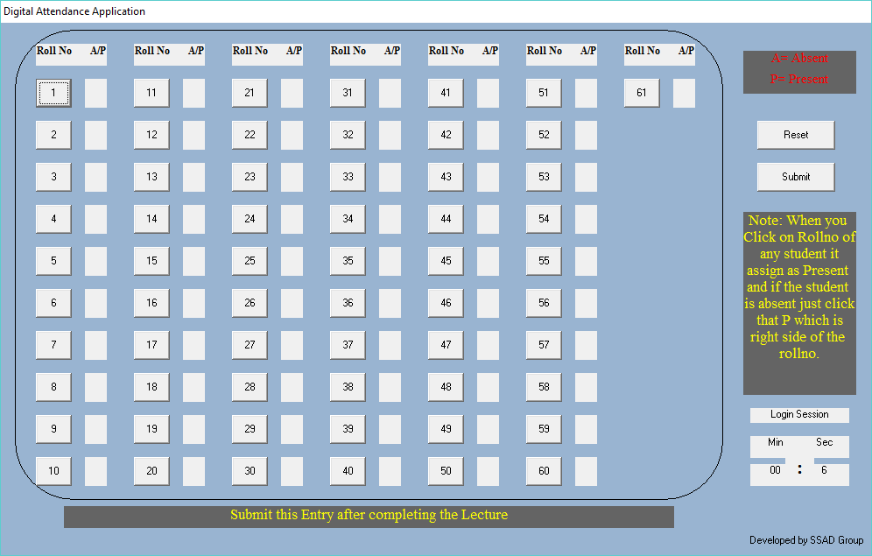

Dim all, p, a As Integer

Dim od1, ot1 As Date

Private Sub Command36_Click()

Label1.Caption = " "

Label2.Caption = " "

Label3.Caption = " "

Label4.Caption = " "

Label5.Caption = " "

End Sub

Private Sub Command1_Click()

Label1.Caption = "P"

End Sub

Private Sub Command2_Click()

Label2.Caption = "P"

End Sub

Private Sub Command3_Click()

Label3.Caption = "P"

End Sub

Private Sub Command4_Click()

Label4.Caption = "P"

End Sub

Private Sub Command5_Click()

Label5.Caption = "P"

End Sub

Private Sub Command6_Click()

Label6.Caption = "P"

End Sub

Private Sub Label1_Click()

Label1.Caption = "A"

End Sub

Private Sub Label2_Click()

Label2.Caption = "A"

End Sub

Private Sub Label3_Click()

Label3.Caption = "A"

End Sub

Private Sub Label4_Click()

Label4.Caption = "A"

End Sub

Private Sub Label5_Click()

Label5.Caption = "A"

End Sub

Private Sub Label6_Click()

Label6.Caption = "A"

End Sub

Private Sub Timer1_Timer()

Label47.Caption = Val(Label47.Caption) + 1

If Val(Label47.Caption) = 60 Then

Label47.Caption = 0

End If

End Sub

Private Sub Timer2_Timer()

Label48.Caption = Val(Label48.Caption) + 1

End Sub

Private Sub Command37_Click()

Label47.Caption = 0

Label48.Caption = 0

Timer1.Enabled = False

Timer2.Enabled = False

od1 = DateValue(Now)

ot1 = TimeValue(Now)

Form8.Text9.Text = od1

Form8.Text14.Text = ot1

Form11.Data4.Recordset.MoveFirst

p = 0

a = 0

If Label1.Caption = "P" Then

p = p + 1

Form11.Data4.Recordset.Edit

Form11.Data4.Recordset.Fields("present").Value = Form11.Data4.Recordset.Fields("present").Value + 1

Form11.Data4.Recordset.Update

ElseIf Label1.Caption = "A" Then

Form9.Text1.Text = Form9.Text1.Text + " 1-" + Form11.Data4.Recordset.Fields!stu_name

a = a + 1

Form11.Data4.Recordset.Edit

Form11.Data4.Recordset.Fields("absent").Value = Form11.Data4.Recordset.Fields("absent").Value + 1

Form11.Data4.Recordset.Update

End If

Form11.Data4.Recordset.MoveNext

If Label2.Caption = "P" Then

p = p + 1

Form11.Data4.Recordset.Edit

Form11.Data4.Recordset.Fields("present").Value = Form11.Data4.Recordset.Fields("present").Value + 1

Form11.Data4.Recordset.Update

ElseIf Label2.Caption = "A" Then

Form9.Text1.Text = Form9.Text1.Text + " 2-" + Form11.Data4.Recordset.Fields!stu_name

a = a + 1

Form11.Data4.Recordset.Edit

Form11.Data4.Recordset.Fields("absent").Value = Form11.Data4.Recordset.Fields("absent").Value + 1

Form11.Data4.Recordset.Update

End If

Form11.Data4.Recordset.MoveNext

If Label3.Caption = "P" Then

p = p + 1

Form11.Data4.Recordset.Edit

Form11.Data4.Recordset.Fields("present").Value = Form11.Data4.Recordset.Fields("present").Value + 1

Form11.Data4.Recordset.Update

ElseIf Label3.Caption = "A" Then

Form9.Text1.Text = Form9.Text1.Text + " 3-" + Form11.Data4.Recordset.Fields!stu_name

a = a + 1

Form11.Data4.Recordset.Edit

Form11.Data4.Recordset.Fields("absent").Value = Form11.Data4.Recordset.Fields("absent").Value + 1

Form11.Data4.Recordset.Update

End If

Form11.Data4.Recordset.MoveNext

If Label4.Caption = "P" Then

p = p + 1

Form11.Data4.Recordset.Edit

Form11.Data4.Recordset.Fields("present").Value = Form11.Data4.Recordset.Fields("present").Value + 1

Form11.Data4.Recordset.Update

ElseIf Label4.Caption = "A" Then

Form9.Text1.Text = Form9.Text1.Text + " 4-" + Form11.Data4.Recordset.Fields!stu_name

a = a + 1

Form11.Data4.Recordset.Edit

Form11.Data4.Recordset.Fields("absent").Value = Form11.Data4.Recordset.Fields("absent").Value + 1

Form11.Data4.Recordset.Update

End If

Form11.Data4.Recordset.MoveNext

If Label5.Caption = "P" Then

p = p + 1

Form11.Data4.Recordset.Edit

Form11.Data4.Recordset.Fields("present").Value = Form11.Data4.Recordset.Fields("present").Value + 1

Form11.Data4.Recordset.Update

ElseIf Label5.Caption = "A" Then

Form9.Text1.Text = Form9.Text1.Text + " 5-" + Form11.Data4.Recordset.Fields!stu_name

a = a + 1

Form11.Data4.Recordset.Edit

Form11.Data4.Recordset.Fields("absent").Value = Form11.Data4.Recordset.Fields("absent").Value + 1

Form11.Data4.Recordset.Update

End If

End Sub

**Attendance Report Form:**

This form includes the attendance of overall class which is selected by lecturer.

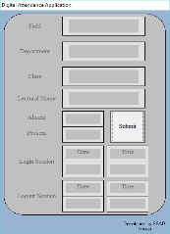

Public de, fd1, fd2, fd3, fd4, fd5, fd6, fd7, fd8 As String

Private Sub Command1_Click()

Me.Hide

Form9.Show

de = Text5.Text + " : " + Text6.Text

fd8 = Text21.Text + " : " + Text22.Text

fd7 = Text20.Text + " : " + Text19.Text

fd6 = Text18.Text + " : " + Text17.Text

fd1 = Text16.Text + " : " + Text15.Text

fd2 = Text3.Text + " : " + Text1.Text

fd3 = Text4.Text + " : " + Text2.Text

fd4 = Text8.Text + "->" + Text11.Text + " : " + Text12.Text

fd5 = Text7.Text + "->" + Text11.Text + " : " + Text14.Text

End Sub

**Absent Student List Form:**

This form shows only the absent students name.

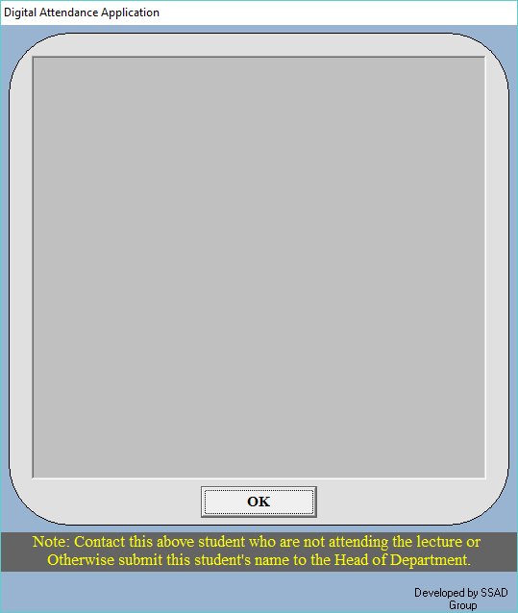

Dim S(12) As String

Private Sub Command1_Click()

Form10.Command3.Visible = True

Form10.Command2.Visible = False

Form10.Command1.Visible = False

S(11) = Form8.de

S(10) = Form8.fd8

S(0) = Form8.fd7

S(1) = Form8.fd6

S(2) = Form8.fd1

S(3) = Form8.fd2

S(4) = Form8.fd3

S(5) = Form8.fd4

S(6) = Form8.fd5

S(7) = "Student Those Who are Absent in the Lecture ::-->"

S(8) = Text1.Text

S(9) = " "

Form10.Text1.Text = S(0)

Form10.Text2.Text = S(1)

Form10.Text3.Text = S(2)

Form10.Text4.Text = S(3)

Form10.Text5.Text = S(4)

Form10.Text6.Text = S(5)

Form10.Text7.Text = S(6)

Form10.Text8.Text = S(7)

Form10.Text9.Text = S(8)

Form10.Text10.Text = S(9)

Form10.Text11.Text = S(10)

Form10.Text12.Text = S(11)

Me.Hide

Form10.Show

End Sub

**Data Preview Form:**

This form displays the attendance report of the class which has to be stored in the database.

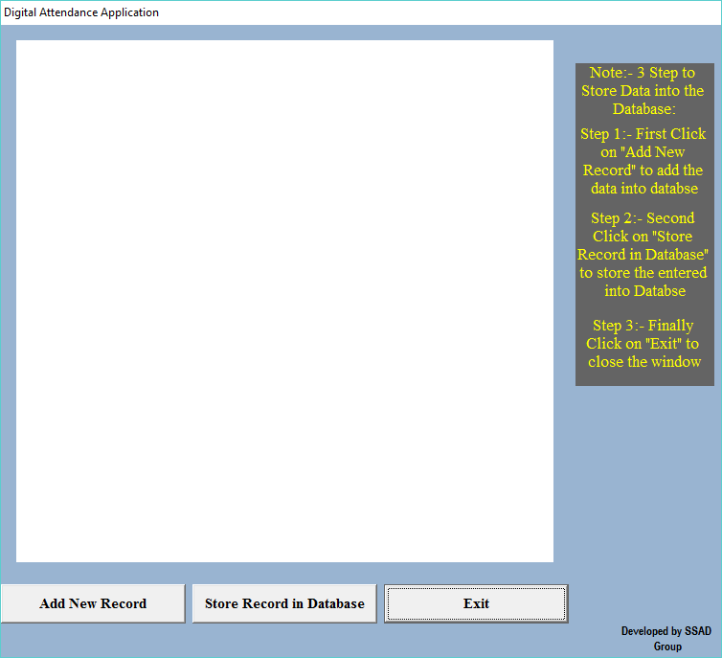

Dim msg, sss As String

Private Sub Command1_Click()

On Error Resume Next

msg = MsgBox("Thank You for Using This Digital Attendance Application. Todays Attendance DataSheet has been Save to the Database", vbOKOnly, "Message")

sss = Form4.rs

Open Form4.l2 + sss + ".txt" For Append As #1

Print #1, Text1.Text

Print #1, Text2.Text

Print #1, Text3.Text

Print #1, Text4.Text

Print #1, Text5.Text

Print #1, Text6.Text

Close #1

Me.Hide

Form12.Show

End Sub

Private Sub Command2_Click()

Form14.rec.Fields("DATE").Value = Form8.Text6.Text

Form14.rec.Fields("DEPT").Value = Form8.Text19.Text

Form14.rec.Fields("CLASS").Value = Form8.Text17.Text

Form14.rec.Fields("LECTURAL").Value = Form8.Text15.Text

Form14.rec.Fields("LOGIN_SESSION").Value = Form8.Text12.Text

Form14.rec.Fields("LOGOUT_SESSION").Value = Form8.Text14.Text

Form14.rec.Fields("PRESENT").Value = Form8.Text2.Text

Form14.rec.Fields("ABSENT").Value = Form8.Text1.Text

Form14.rec.Update

Command2.Visible = False

Command1.Visible = True

End Sub

Private Sub Command3_Click()

On Error Resume Next

Form14.rec.AddNew

Command3.Visible = False

Command2.Visible = True

End Sub

Private Sub Form_Load()

On Error Resume Next

Set Form14.DataGrid1.DataSource = Form14.rec

End Sub

Private Sub Text13_Change()

End Sub

**Open Database Form:**

This form shows the database of the overall department.

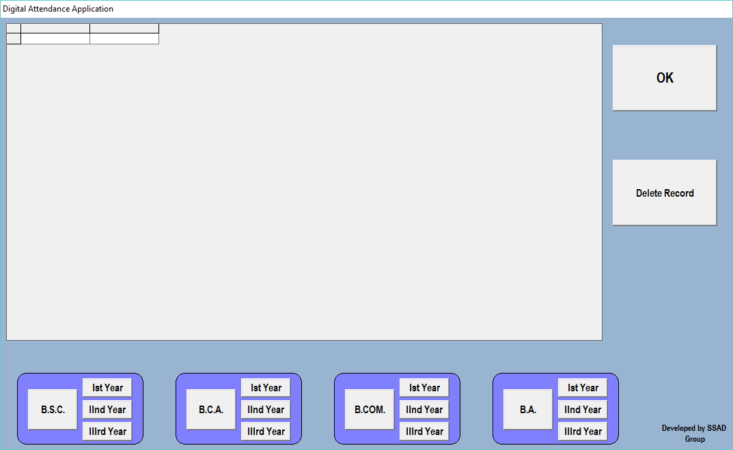

Public con As New ADODB.Connection

Public rec As New ADODB.Recordset

Private Sub Command1_Click()

Form12.Show

Me.Hide

End Sub

Private Sub Command10_Click()

con.Close

con.Open "Provider= Microsoft.jet.OLEDB.4.0;Data source=C:\Database\database.mdb;"

rec.CursorLocation = adUseClient

DataGrid1.Refresh

rec.Open "select * from data where DEPT = 'B.C.A.' And CLASS = 'Ist Year'", con, adOpenDynamic, adLockOptimistic

If rec.EOF Then

MsgBox "no record found"

Else

Set DataGrid1.DataSource = rec

End If

End Sub

Private Sub Command11_Click()

con.Close

con.Open "Provider= Microsoft.jet.OLEDB.4.0;Data source=C:\Database\database.mdb;"

rec.CursorLocation = adUseClient

DataGrid1.Refresh

rec.Open "select * from data where DEPT = 'B.C.A.' And CLASS = 'IInd Year'", con, adOpenDynamic, adLockOptimistic

If rec.EOF Then

MsgBox "no record found"

Else

Set DataGrid1.DataSource = rec

End If

End Sub

Private Sub Command12_Click()

con.Close

con.Open "Provider= Microsoft.jet.OLEDB.4.0;Data source=C:\Database\database.mdb;"

rec.CursorLocation = adUseClient

DataGrid1.Refresh

rec.Open "select * from data where DEPT = 'B.C.A.' And CLASS = 'IIIrd Year'", con, adOpenDynamic, adLockOptimistic

If rec.EOF Then

MsgBox "no record found"

Else

Set DataGrid1.DataSource = rec

End If

End Sub

Private Sub Command13_Click()

con.Close

con.Open "Provider= Microsoft.jet.OLEDB.4.0;Data source=C:\Database\database.mdb;"

rec.CursorLocation = adUseClient

DataGrid1.Refresh

rec.Open "select * from data where DEPT = 'B.COM.'", con, adOpenDynamic, adLockOptimistic

If rec.EOF Then

MsgBox "no record found"

Else

Set DataGrid1.DataSource = rec

End If

End Sub

Private Sub Command14_Click()

con.Close

con.Open "Provider= Microsoft.jet.OLEDB.4.0;Data source=C:\Database\database.mdb;"

rec.CursorLocation = adUseClient

DataGrid1.Refresh

rec.Open "select * from data where DEPT = 'B.COM.' And CLASS = 'Ist Year'", con, adOpenDynamic, adLockOptimistic

If rec.EOF Then

MsgBox "no record found"

Else

Set DataGrid1.DataSource = rec

End If

End Sub

Private Sub Command15_Click()

con.Close

con.Open "Provider= Microsoft.jet.OLEDB.4.0;Data source=C:\Database\database.mdb;"

rec.CursorLocation = adUseClient

DataGrid1.Refresh

rec.Open "select * from data where DEPT = 'B.COM.' And CLASS = 'IInd Year'", con, adOpenDynamic, adLockOptimistic

If rec.EOF Then

MsgBox "no record found"

Else

Set DataGrid1.DataSource = rec

End If

End Sub

Private Sub Command16_Click()

con.Close

con.Open "Provider= Microsoft.jet.OLEDB.4.0;Data source=C:\Database\database.mdb;"

rec.CursorLocation = adUseClient

DataGrid1.Refresh

rec.Open "select * from data where DEPT = 'B.COM.' And CLASS = 'IIIrd Year'", con, adOpenDynamic, adLockOptimistic

If rec.EOF Then

MsgBox "no record found"

Else

Set DataGrid1.DataSource = rec

End If

End Sub

Private Sub Command17_Click()

con.Close

con.Open "Provider= Microsoft.jet.OLEDB.4.0;Data source=C:\Database\database.mdb;"

rec.CursorLocation = adUseClient

DataGrid1.Refresh

rec.Open "select * from data where DEPT = 'B.A.'", con, adOpenDynamic, adLockOptimistic

If rec.EOF Then

MsgBox "no record found"

Else

Set DataGrid1.DataSource = rec

End If

End Sub

Private Sub Command18_Click()

con.Close

con.Open "Provider= Microsoft.jet.OLEDB.4.0;Data source=C:\Database\database.mdb;"

rec.CursorLocation = adUseClient

DataGrid1.Refresh

rec.Open "select * from data where DEPT = 'B.A.' And CLASS = 'Ist Year'", con, adOpenDynamic, adLockOptimistic

If rec.EOF Then

MsgBox "no record found"

Else

Set DataGrid1.DataSource = rec

End If

End Sub

Private Sub Command19_Click()

con.Close

con.Open "Provider= Microsoft.jet.OLEDB.4.0;Data source=C:\Database\database.mdb;"

rec.CursorLocation = adUseClient

DataGrid1.Refresh

rec.Open "select * from data where DEPT = 'B.A.' And CLASS = 'IInd Year'", con, adOpenDynamic, adLockOptimistic

If rec.EOF Then

MsgBox "no record found"

Else

Set DataGrid1.DataSource = rec

End If

End Sub

Private Sub Command2_Click()

Form12.Show

Me.Hide

Form14.con.Close

Form14.con.Open "Provider= Microsoft.jet.OLEDB.4.0;Data source=C:\Database\database.mdb;"

Form14.rec.CursorLocation = adUseClient

Form14.rec.Open "select * from data", con, adOpenDynamic, adLockOptimistic

Form14.DataGrid1.Refresh

End Sub

Private Sub Command20_Click()

con.Close

con.Open "Provider= Microsoft.jet.OLEDB.4.0;Data source=C:\Database\database.mdb;"

rec.CursorLocation = adUseClient

DataGrid1.Refresh

rec.Open "select * from data where DEPT = 'B.A.' And CLASS = 'IIIrd Year'", con, adOpenDynamic, adLockOptimistic

If rec.EOF Then

MsgBox "no record found"

Else

Set DataGrid1.DataSource = rec

End If

End Sub

Private Sub Command3_Click()

con.Close

con.Open "Provider= Microsoft.jet.OLEDB.4.0;Data source=C:\Database\database.mdb;"

rec.CursorLocation = adUseClient

DataGrid1.Refresh

rec.Open "select * from data", con, adOpenDynamic, adLockOptimistic

Set DataGrid1.DataSource = rec

End Sub

Private Sub Command4_Click()

On Error Resume Next

rec.Delete

End Sub

Private Sub Command5_Click()

con.Close

con.Open "Provider= Microsoft.jet.OLEDB.4.0;Data source=C:\Database\database.mdb;"

rec.CursorLocation = adUseClient

DataGrid1.Refresh

rec.Open "select * from data where DEPT = 'B.S.C.'", con, adOpenDynamic, adLockOptimistic

If rec.EOF Then

MsgBox "no record found"

Else

Set DataGrid1.DataSource = rec

End If

End Sub

Private Sub Command6_Click()

con.Close

con.Open "Provider= Microsoft.jet.OLEDB.4.0;Data source=C:\Database\database.mdb;"

rec.CursorLocation = adUseClient

DataGrid1.Refresh

rec.Open "select * from data where DEPT = 'B.S.C.' And CLASS = 'Ist Year'", con, adOpenDynamic, adLockOptimistic

If rec.EOF Then

MsgBox "no record found"

Else

Set DataGrid1.DataSource = rec

End If

End Sub

Private Sub Command7_Click()

con.Close

con.Open "Provider= Microsoft.jet.OLEDB.4.0;Data source=C:\Database\database.mdb;"

rec.CursorLocation = adUseClient

DataGrid1.Refresh

rec.Open "select * from data where DEPT = 'B.S.C.' And CLASS = 'IInd Year'", con, adOpenDynamic, adLockOptimistic

If rec.EOF Then

MsgBox "no record found"

Else

Set DataGrid1.DataSource = rec

End If

End Sub

Private Sub Command8_Click()

con.Close

con.Open "Provider= Microsoft.jet.OLEDB.4.0;Data source=C:\Database\database.mdb;"

rec.CursorLocation = adUseClient

DataGrid1.Refresh

rec.Open "select * from data where DEPT = 'B.S.C.' And CLASS = 'IIIrd Year'", con, adOpenDynamic, adLockOptimistic

If rec.EOF Then

MsgBox "no record found"

Else

Set DataGrid1.DataSource = rec

End If

End Sub

Private Sub Command9_Click()

con.Close

con.Open "Provider= Microsoft.jet.OLEDB.4.0;Data source=C:\Database\database.mdb;"

rec.CursorLocation = adUseClient

DataGrid1.Refresh

rec.Open "select * from data where DEPT = 'B.C.A.'", con, adOpenDynamic, adLockOptimistic

If rec.EOF Then

MsgBox "no record found"

Else

Set DataGrid1.DataSource = rec

End If

End Sub

Private Sub Form_Load()

con.Open "Provider= Microsoft.jet.OLEDB.4.0;Data source=C:\Database\database.mdb;"

rec.CursorLocation = adUseClient

DataGrid1.Refresh

rec.Open "select * from data", con, adOpenDynamic, adLockOptimistic

End Sub

**Register Form:**

This form is used to join the new student into the database.

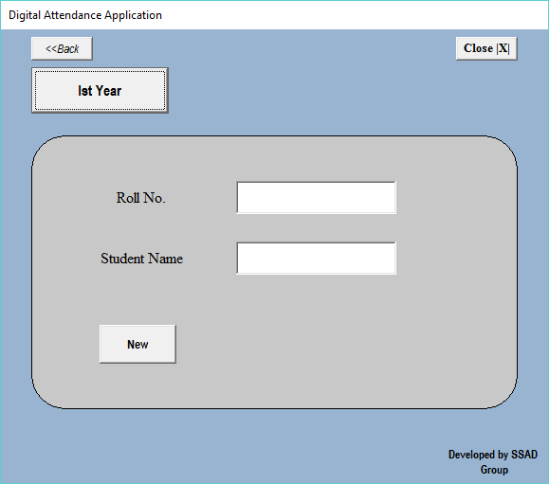

Public sely As Integer

Private Sub Command1_Click()

Shape1.Visible = True

Label1.Visible = True

Label2.Visible = True

Text1.Visible = True

Text2.Visible = True

Command5.Visible = True

Command2.Visible = False

Command3.Visible = False

Command4.Visible = True

sely = 0

Text1.Enabled = False

Text2.Enabled = False

End Sub

Private Sub Command19_Click()

Shape1.Visible = False

Label1.Visible = False

Label2.Visible = False

Text1.Visible = False

Text1.Text = ""

Text2.Visible = False

Text2.Text = ""

Command4.Visible = False

Command5.Visible = False

Command6.Visible = False

Command7.Visible = False

Command1.Visible = True

Command2.Visible = True

Command3.Visible = True

Me.Hide

Form12.Show

End Sub

Private Sub Command2_Click()

Shape1.Visible = True

Label1.Visible = True

Label2.Visible = True

Text1.Visible = True

Text2.Visible = True

Command5.Visible = True

Command1.Visible = False

Command3.Visible = False

Command4.Visible = True

sely = 1

Text1.Enabled = False

Text2.Enabled = False

End Sub

Private Sub Command3_Click()

Shape1.Visible = True

Label1.Visible = True

Label2.Visible = True

Text1.Visible = True

Text2.Visible = True

Command5.Visible = True

Command2.Visible = False

Command1.Visible = False

Command4.Visible = True

sely = 2

Text1.Enabled = False

Text2.Enabled = False

End Sub

Private Sub Command4_Click()

Shape1.Visible = False

Label1.Visible = False

Label2.Visible = False

Text1.Visible = False

Text1.Text = ""

Text2.Visible = False

Text2.Text = ""

Command4.Visible = False

Command5.Visible = False

Command6.Visible = False

Command7.Visible = False

Command1.Visible = True

Command2.Visible = True

Command3.Visible = True

End Sub

Private Sub Command5_Click()

On Error Resume Next

If Form12.sel = 0 Then

Select Case sely

Case 0

Form11.Data4.Recordset.MoveLast

Form11.Data4.Recordset.AddNew

Text1.Enabled = True

Text2.Enabled = True

Text1.SetFocus

Case 1

Form11.Data5.Recordset.MoveLast

Form11.Data5.Recordset.AddNew

Text1.Enabled = True

Text2.Enabled = True

Text1.SetFocus

Case 2

Form11.Data6.Recordset.MoveLast

Form11.Data6.Recordset.AddNew

Text1.Enabled = True

Text2.Enabled = True

Text1.SetFocus

End Select

ElseIf Form12.sel = 1 Then

Select Case sely

Case 0

Form11.Data10.Recordset.MoveLast

Form11.Data10.Recordset.AddNew

Text1.Enabled = True

Text2.Enabled = True

Text1.SetFocus

Case 1

Form11.Data11.Recordset.MoveLast

Form11.Data11.Recordset.AddNew

Text1.Enabled = True

Text2.Enabled = True

Text1.SetFocus

Case 2

Form11.Data12.Recordset.MoveLast

Form11.Data12.Recordset.AddNew

Text1.Enabled = True

Text2.Enabled = True

Text1.SetFocus

End Select

ElseIf Form12.sel = 2 Then

Select Case sely

Case 0

Form11.Data7.Recordset.MoveLast

Form11.Data7.Recordset.AddNew

Text1.Enabled = True

Text2.Enabled = True

Text1.SetFocus

Case 1

Form11.Data8.Recordset.MoveLast

Form11.Data8.Recordset.AddNew

Text1.Enabled = True

Text2.Enabled = True

Text1.SetFocus

Case 2

Form11.Data9.Recordset.MoveLast

Form11.Data9.Recordset.AddNew

Text1.Enabled = True

Text2.Enabled = True

Text1.SetFocus

End Select

ElseIf Form12.sel = 3 Then

Select Case sely

Case 0

Form11.Data1.Recordset.MoveLast

Form11.Data1.Recordset.AddNew

Text1.Enabled = True

Text2.Enabled = True

Text1.SetFocus

Case 1

Form11.Data2.Recordset.MoveLast

Form11.Data2.Recordset.AddNew

Text1.Enabled = True

Text2.Enabled = True

Text1.SetFocus

Case 2

Form11.Data3.Recordset.MoveLast

Form11.Data3.Recordset.AddNew

Text1.Enabled = True

Text2.Enabled = True

Text1.SetFocus

End Select

End If

Command6.Visible = True

Command5.Visible = False

End Sub

Private Sub Command6_Click()

On Error Resume Next

If Form12.sel = 0 Then

Select Case sely

Case 0

Form11.Data4.Recordset.Fields("rollno").Value = Text1.Text

Form11.Data4.Recordset.Fields("stu_name").Value = Text2.Text

Form11.Data4.Recordset.Fields("present").Value = 0

Form11.Data4.Recordset.Fields("absent").Value = 0

Form11.Data4.Recordset.Update

Case 1

Form11.Data5.Recordset.Fields("rollno").Value = Text1.Text

Form11.Data5.Recordset.Fields("stu_name").Value = Text2.Text

Form11.Data5.Recordset.Fields("present").Value = 0

Form11.Data5.Recordset.Fields("absent").Value = 0

Form11.Data5.Recordset.Update

Case 2

Form11.Data6.Recordset.Fields("rollno").Value = Text1.Text

Form11.Data6.Recordset.Fields("stu_name").Value = Text2.Text

Form11.Data6.Recordset.Fields("present").Value = 0

Form11.Data6.Recordset.Fields("absent").Value = 0

Form11.Data6.Recordset.Update

End Select

ElseIf Form12.sel = 1 Then

Select Case sely

Case 0

Form11.Data10.Recordset.Fields("rollno").Value = Text1.Text

Form11.Data10.Recordset.Fields("stu_name").Value = Text2.Text

Form11.Data10.Recordset.Fields("present").Value = 0

Form11.Data10.Recordset.Fields("absent").Value = 0

Form11.Data10.Recordset.Update

Case 1

Form11.Data11.Recordset.Fields("rollno").Value = Text1.Text

Form11.Data11.Recordset.Fields("stu_name").Value = Text2.Text

Form11.Data11.Recordset.Fields("present").Value = 0

Form11.Data11.Recordset.Fields("absent").Value = 0

Form11.Data11.Recordset.Update

Case 2

Form11.Data12.Recordset.Fields("rollno").Value = Text1.Text

Form11.Data12.Recordset.Fields("stu_name").Value = Text2.Text

Form11.Data12.Recordset.Fields("present").Value = 0

Form11.Data12.Recordset.Fields("absent").Value = 0

Form11.Data12.Recordset.Update

End Select

ElseIf Form12.sel = 2 Then

Select Case sely

Case 0

Form11.Data7.Recordset.Fields("rollno").Value = Text1.Text

Form11.Data7.Recordset.Fields("stu_name").Value = Text2.Text

Form11.Data7.Recordset.Fields("present").Value = 0

Form11.Data7.Recordset.Fields("absent").Value = 0

Form11.Data7.Recordset.Update

Case 1

Form11.Data8.Recordset.Fields("rollno").Value = Text1.Text

Form11.Data8.Recordset.Fields("stu_name").Value = Text2.Text

Form11.Data8.Recordset.Fields("present").Value = 0

Form11.Data8.Recordset.Fields("absent").Value = 0

Form11.Data8.Recordset.Update

Case 2

Form11.Data9.Recordset.Fields("rollno").Value = Text1.Text

Form11.Data9.Recordset.Fields("stu_name").Value = Text2.Text

Form11.Data9.Recordset.Fields("present").Value = 0

Form11.Data9.Recordset.Fields("absent").Value = 0

Form11.Data9.Recordset.Update

End Select

ElseIf Form12.sel = 3 Then

Select Case sely

Case 0

Form11.Data1.Recordset.Fields("rollno").Value = Text1.Text

Form11.Data1.Recordset.Fields("stu_name").Value = Text2.Text

Form11.Data1.Recordset.Fields("present").Value = 0

Form11.Data1.Recordset.Fields("absent").Value = 0

Form11.Data1.Recordset.Update

Case 1

Form11.Data2.Recordset.Fields("rollno").Value = Text1.Text

Form11.Data2.Recordset.Fields("stu_name").Value = Text2.Text

Form11.Data2.Recordset.Fields("present").Value = 0

Form11.Data2.Recordset.Fields("absent").Value = 0

Form11.Data2.Recordset.Update

Case 2

Form11.Data3.Recordset.Fields("rollno").Value = Text1.Text

Form11.Data3.Recordset.Fields("stu_name").Value = Text2.Text

Form11.Data3.Recordset.Fields("present").Value = 0

Form11.Data3.Recordset.Fields("absent").Value = 0

Form11.Data3.Recordset.Update

End Select

End If

Command7.Visible = True

Command6.Visible = False

MsgBox "New Record has Been Added to Your Database", vbInformation, "Saved"

End Sub

Private Sub Command7_Click()

Text1.Text = ""

Text2.Text = ""

Shape1.Visible = False

Label1.Visible = False

Label2.Visible = False

Text1.Visible = False

Text1.Text = ""

Text2.Visible = False

Text2.Text = ""

Command4.Visible = False

Command5.Visible = False

Command6.Visible = False

Command7.Visible = False

Command1.Visible = True

Command2.Visible = True

Command3.Visible = True

Me.Hide

Form12.Show

End Sub

**Search Form:**

This form help to find out the student from the department which is selected.

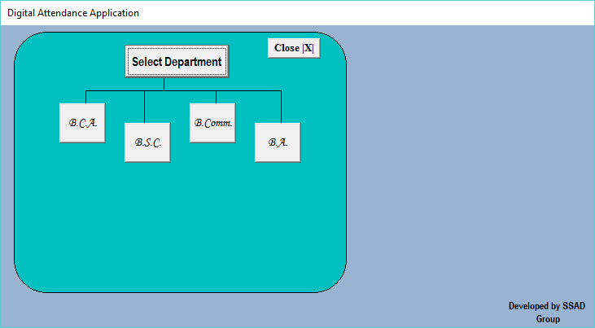

Private Sub Command19_Click()

Me.Hide

Form12.Show

Line16.Visible = True

Line17.Visible = True

Line18.Visible = True

Line19.Visible = True

Line20.Visible = True

Line21.Visible = True

Command2.Visible = True

Command3.Visible = True

Command4.Visible = True

Command5.Visible = True

Line1.Visible = False

Line2.Visible = False

Line3.Visible = False

Line4.Visible = False

Command6.Visible = False

Command7.Visible = False

Command8.Visible = False

Line5.Visible = False

Line6.Visible = False

Line11.Visible = False

Line12.Visible = False

Command9.Visible = False

Command10.Visible = False

Command11.Visible = False

End Sub

Private Sub Command17_Click()

Adodc1.RecordSource = "select * from BA2nd"

Adodc1.Refresh

Line13.Visible = False

Line22.Visible = False

Command16.Visible = False

Command15.Visible = False

DataGrid1.Visible = True

End Sub

**Conclusion:-**

**The Digital Attendance Applicationis developed using**

**Visual Basic 6.0 fully meets the objectives of the system**

**which it has been developed. The system has reached a**

**steady state where all bugs have been eliminated. The**

**system is operated at a high level of efficiency and all the**

**teachers and user associated with the system understands its advantage. The system solves the problem. It was intended to solve as requirement specification.**

**Reference:-**

* Visual Basic 6.0 By Reference Book.
* www.Google.com
* www.vbtutorial.com